IBM BPM V8.5.x to V8.5.6.0 Upgrade  
  
To upgrade from IBM Business Process Manager Advanced or IBM Business Process Manager Standard V8.5.x to V8.5.6 cf2, follow the instructions to back up your existing profiles and host, install the V8.5.6 refresh pack onto the deployment manager and each managed node, upgrade your Process Server database, and restart the deployment manager and nodes. The scope of this document includes the products BPM v8.5.6.2, DB2 v10.5 and SuSe v11 for Linux 64bit Z series.  
  
**Procedure** 

1. Verify that your target environment - including hardware, operating systems, and database prerequisites - is a supported operating environment for IBM Business Process Manager V8.5.6. See [IBM Business Process Manager Advanced system requirements](http://www.ibm.com/software/integration/business-process-manager/advanced/sysreqs/) or [IBM Business Process Manager Standard system requirements](http://www.ibm.com/software/integration/business-process-manager/standard/sysreqs/).  
   **Tip**: If the database requirements have changed, move to the new database version and make sure that IBM Business Process Manager is working correctly before you proceed with the upgrade.
2. V8.5 Refresh Pack 6 updates the core product files and all the existing profiles that require a maintenance update. Before you upgrade your existing installation,
3. Verify if the existing environment has no issues and operational by login to Compass.
4. **Removing/Cleaning up the older (inactive, stopped & undeployed) snapshots:**

Prior to follow the below steps for delete snapshots, using data studio connect to BPMDB on BPM DB2 server and run the following select statements to query the required format of snapshots in different state. Other wise manual steps will be very time consuming and painful.

Examples of select statements to create a jython sytax command :

|  |
| --- |
| **Step 1**: Execute the below statement and take the output and copy to a file Ex: ‘BPMSnapshotsToStop.py’  *select ' print AdminTask.BPMDeactivate(''' || '-containerAcronym TENR -containerSnapshotAcronym ' || ACRONYM || ']' || '''' || ')' from db2inst1.lsw_snapshot where name like 'TENR%' and IS_DEFAULT = 'F' and IS_ACTIVE = 'T'*  Output Example to deactivate the snapshot:  print AdminTask.BPMDeactivate('-containerAcronym TENR -containerSnapshotAcronym TENR201]') |
| **Step 2**: Execute the below statement and take the output and copy to a file Ex: ‘BPMSnapshotsToUndeploy.py’  *select ' print AdminTask.BPMStop(''' || '-containerAcronym TENR -containerSnapshotAcronym ' || ACRONYM || ']' || '''' || ')' from db2inst1.lsw_snapshot where name like 'TENR%' and IS_DEFAULT = 'F' and IS_ACTIVE = 'F' and IS_ARCHIVED = 'F'*  Output Example:  print AdminTask.BPMStop('-containerAcronym TENR -containerSnapshotAcronym TENR201]') |
| **Step 3**: Execute the below statement and take the output and copy to a file Ex: ‘BPMSnapshotsToDelete.py’  *select ' print AdminTask.BPMUndeploy(''' || '-containerAcronym TENR -containerSnapshotAcronym ' || ACRONYM || ']' || '''' || ')' from db2inst1.lsw_snapshot where name like 'TENR%' and IS_DEFAULT = 'F' and IS_ACTIVE = 'F' and IS_ARCHIVED = 'F'*  Output Example:  print AdminTask.BPMUndeploy('-containerAcronym TENR -containerSnapshotAcronym TENR201]') |
| **Step 4**: Create a shell script ‘BPMSnapshots_cmd.sh’ and add the 4 commands and uncomment each line in a sequence.  *select ' print AdminTask.BPMDeleteSnapshot(''' || '-containerAcronym TENR -containerSnapshotAcronyms ' || ACRONYM || ']' || '''' || ')' from db2inst1.lsw_snapshot where name like 'TENR%'*  Output Example:  print AdminTask.BPMDeleteSnapshot('-containerAcronym TENR -containerSnapshotAcronym TENR201]') |

(Note: Above ‘BPMDeleteSnapshot’ syntax format works only if the snapshot is in undeployed state. So to use the above syntax, all the sanpshots must bring down from inactive to stopped to undeployed state and collect and copy all the print commands to **BPMDeleteSnapshot.py** and finally execute the wsadmin.sh script as shown below).

To delete a snapshot one after one manually, :

{

Ssh to BPM Process Server,

Execute the script,

* 1. To delete one snapshot at a time,

*/wasprofiles/profiles/*/bin/wsadmin.sh -conntype SOAP -port 8880 -host wlabps01 -lang jython*

*Wasadmin>* print AdminTask.BPMDeleteSnapshot('-containerAcronym TENR -containerSnapshotAcronym TENR201]')

* 1. To delete all of them together from .py file,

*/wasprofiles/profiles/*/bin/wsadmin.sh -conntype SOAP -port 8880 -host wlabps01 -lang jython -f ./BPMDeleteSnapshot.py*

*(Note: Please update the BPMSnapshots_cmd.py with Show, Deactivate, Stop, Undeploy and Delete commands as shown in the example below)*

Command level BPM Admin task examples:**“**

*wsg1ps01:/wasprofiles/profiles/SG1PS01/bin # cat BPMSnapshots_cmd.py*

*#######################################################################################################################*

*#*

*# Examples of syntax commands*

*# To Deactivate - print AdminTask.****BPMDeactivate****('[-containerAcronym TENR -containerSnapshotAcronym TEN_344]')*

*# To Stop - print AdminTask.****BPMStop****('[-containerAcronym TENR -containerSnapshotAcronym TEN_344]')*

*# To Undeploy - print AdminTask.****BPMUndeploy****('[-containerAcronym TENR -containerSnapshotAcronym TEN_344]')*

*# To Delete - print AdminTask.****BPMDeleteSnapshot****('[-containerAcronym TENR -containerSnapshotAcronym****s*** *TEN_344]')*

*# To Show - print AdminTask.****BPMShowProcessApplication****('[-containerAcronym TENR]')*

*#*

*######################################################################################################################*

*print AdminTask.BPMShowProcessApplication('[-containerAcronym TENR]')*

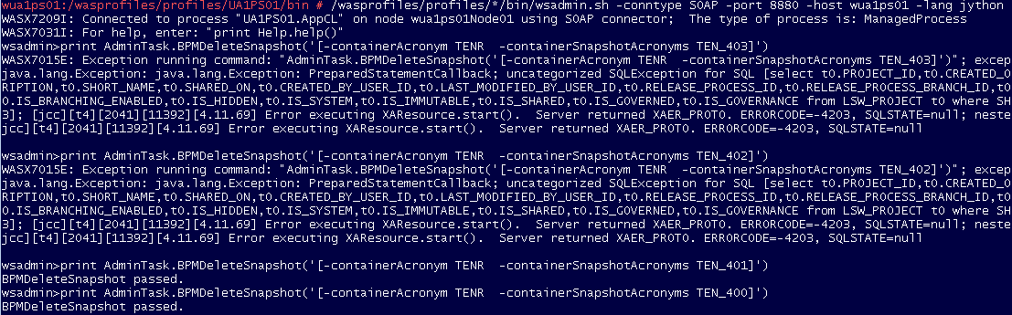

**Note: If any of the snapshot deletion failed with sql error as shown in above screenshot please contact DBA to clear any locks on tables**.

}

1. From Process Server ProcessAdmin console >process inspector search the instances by time and delete them as required as shown in screenshot.

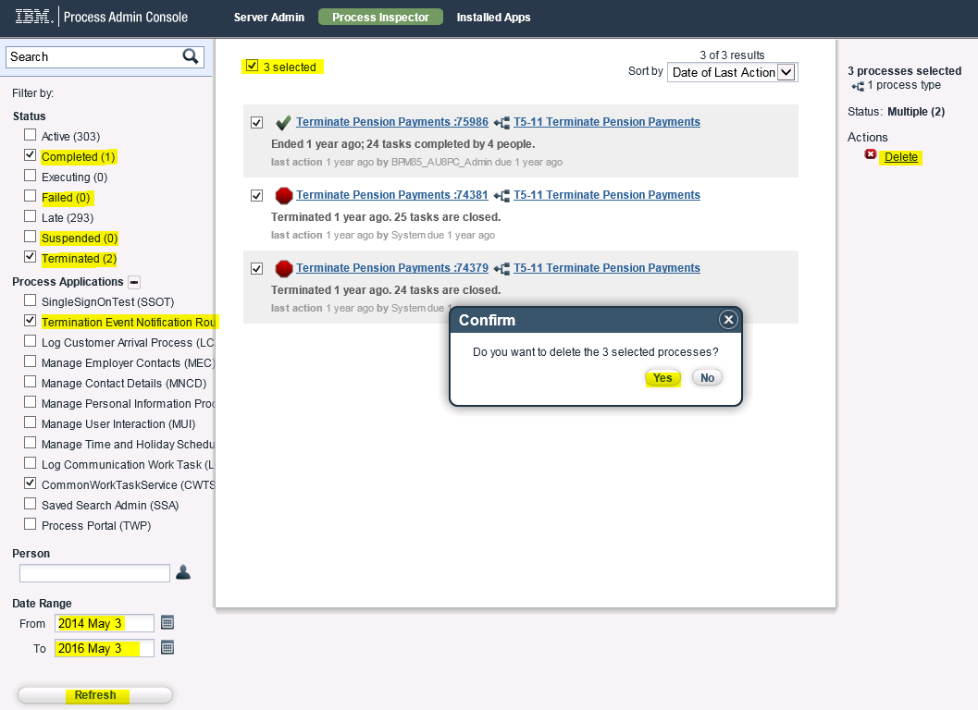

1. Login to Process Server Deployment Manager (Adminconsole) and delete all failed events as shown below.

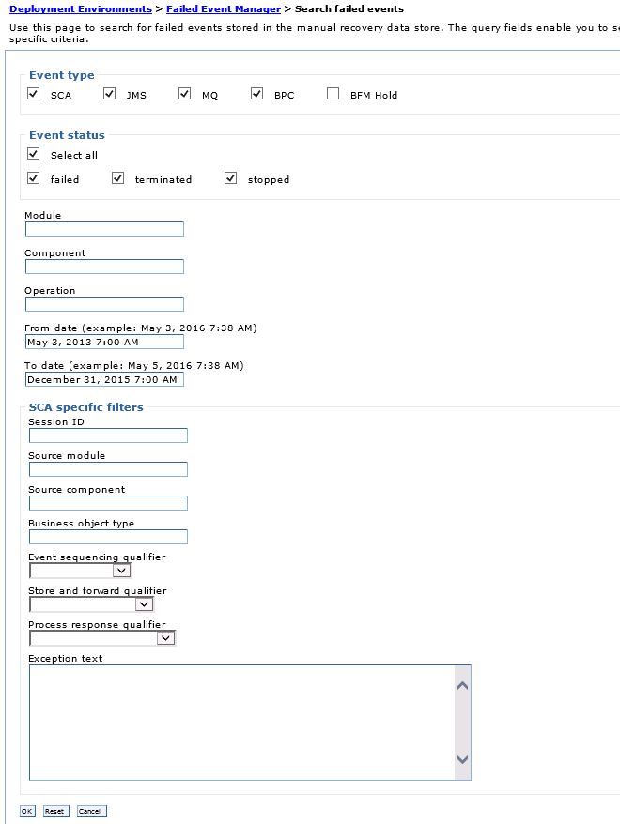

1. If required upgrade DB2 server (Follow instructions for DB2 upgrade)

Below steps outlines the DB2 V10.1 upgrade to DB2 V10.5:

IBM Upgrade Documentation Link:

<http://www-01.ibm.com/support/knowledgecenter/SSEPGG_10.5.0/com.ibm.db2.luw.qb.upgrade.doc/doc/t0007187.html>

1. Backup the existing databases

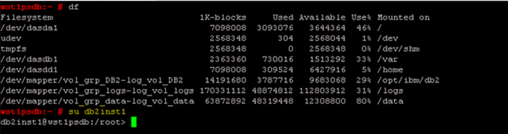

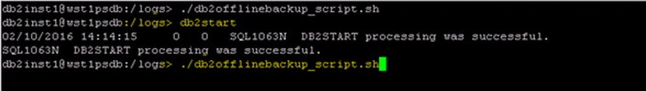

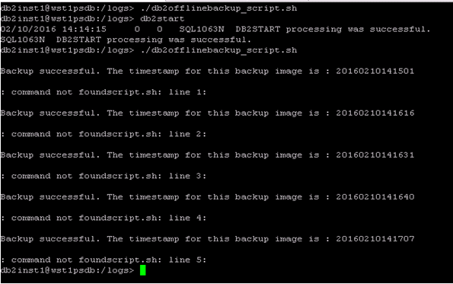

1. Execute the DB2 CheckUpgrade command

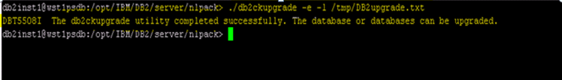

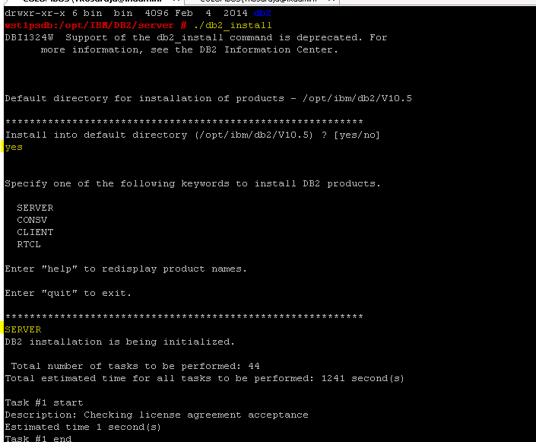

1. **DB2 instance Upgrade after installing the Binaries:**

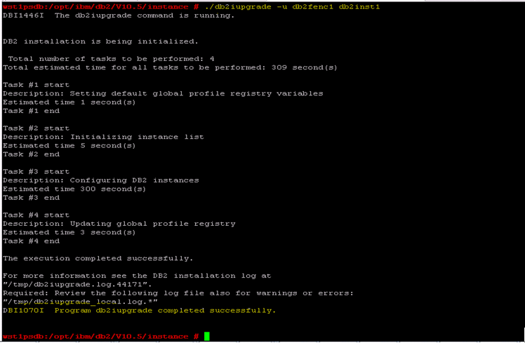

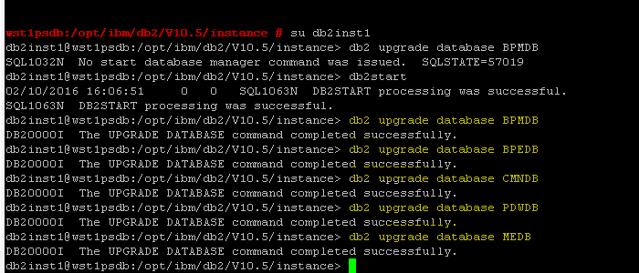

1. DB2 Offline backups(Post Upgrade):

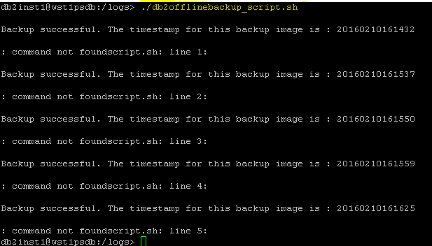

1. Backup DB2 server host (send a request to zVM admins to backup the host)
2. Validate the db2 upgrade by starting existing BPM version environment and get the confirmation from developer’s team.
3. Stop all Java™ processes that are associated with the Java SDK that is installed with IBM Business Process Manager.
4. **Back up your BPM server profiles (Ex: Dmgr01, LABPS01 and LABPS02) to /repo/host_backup/**

( Note: Make sure filesystem **/repo** is mounted, readable and executable using ‘df –h’)

Ssh to each BPM host (Ex: wlabpsdm, wlabps01 & wlabps02) and tar the profile,

***tar –cvf /logs/Dmgr01.tar /wasprofiles/profiles/Dmgr01,***

***tar –cvf /logs/LABPS01.tar /wasprofiles/profiles/LABPS01  
tar –cvf /logs/LABPS02.tar /wasprofiles/profiles/LABPS02***

1. Verify Installation packages (Installation Manager v1.8.4, WAS v8.5.5.8, Java v7.1, BPM v8.5.6 cf2) in lxrepo repository server. If some reason these packages doesn’t work remotely then copy them to local filesystems and them as new repositories in Installation Manager (IM).

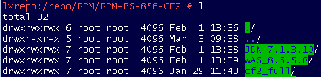

1. Your first BPM upgrade step starts with Deployment Manager,

(Follow this technote for more information [Installing Version 8.5.6.0 Cumulative Fix 2](http://www-01.ibm.com/support/docview.wss?uid=swg27047002) )

1. ssh to the host that has BPM deployment manager running

(In this install process we will be using xwindows, and make sure you have xWindows server running on your desktop and putty session configured for X11 forwarding).

1. Start the installation Manager(IM) (Note: Steps using IM are not always consistent) from this location

***/opt/IBM/BPM_Install_Files/InstallationManager/eclipse/launcher***

1. Update Installation Manager to latest version Ex: v1.8.4
2. Uninstall all ifixes (only) as shown in the screen shot

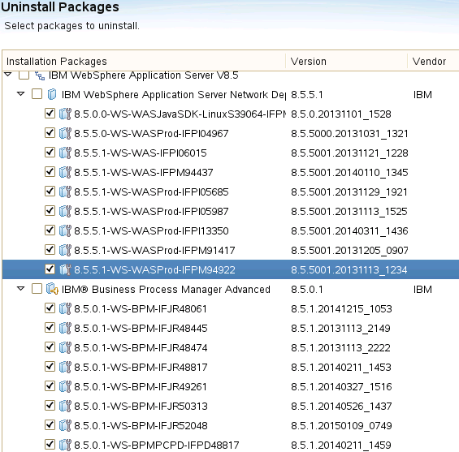

1. Add repositories for WAS v8.5.5.8, BPM v8.5.6 cf2 and SDK v7.1.10 as shown in the screenshot.

/repo/BPM/BPM-PS-856-CF2/WAS_8.5.5.8/repository.config

/repo/BPM/BPM-PS-856-CF2/cf2_full/repository.config

/repo/BPM/BPM-PS-856-CF2/JDK_7.1.3.10/repository.config

**(Note: My observation is the above repositories work only if lxrepo host resides in the same subnet that the process server is. Otherwise you will be depending on using IBM site repositories by enable the search IBM sites in preferences>repositories and this could be very time consuming).**

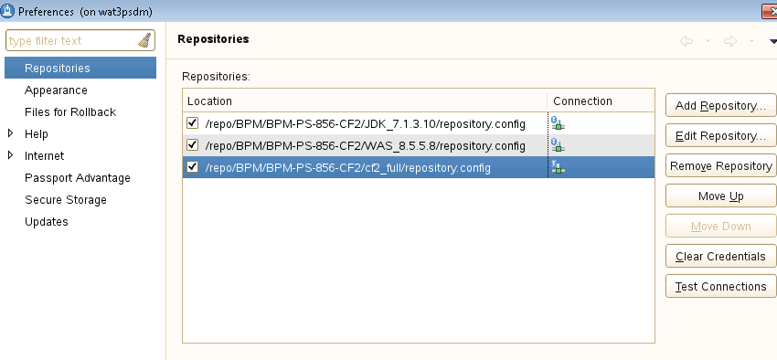

1. Install the V8.5.6 refresh pack onto the deployment manager installation. Follow the [Installation instructions for IBM Business Process Manager Version 8.5 Refresh Pack 6](http://www.ibm.com/support/docview.wss?uid=swg27044939#instFixPk).

Note: Make sure all hosts are open (no blocks on network) to connect to IBM sites and able to install the packages including ifixes as shown in the screen shot below. Sometimes IM will not pick up local repositories (problem could be unable to read the repository files) and it will try to download all the required files again or try copy the package files to another local file system. You need to uncheck the ‘recommended’ box to see all the version and choose the right version from the list.

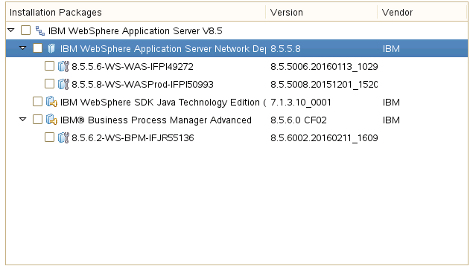

1. Install the V8.5.6 refresh pack onto all managed node installations. Follow the[Installation instructions for IBM Business Process Manager Version 8.5 Refresh Pack 6](http://www.ibm.com/support/docview.wss?uid=swg27044939#instFixPk).
2. Java Upgrade for each host:

Select IBM WebSphere SDK Java TE 7 or 7.1 and complete the installation process. New profiles you create will use Java 7 or 7.1.

Note: You have select Install option to lay down new version of Java and it install it in a separate folder and later it require to reconfigure each JVM on the host to the new Java version.

1. **Optional**: If you created the IBM Business Process Manager V8.5.x environment without using the BPMConfig command or you do not have a complete configuration properties file, you must complete the following steps to generate the file:
2. Run the BPMConfig.sh command in the following order of upgrade.

***/opt/IBM/WebSphere/AppServer/bin/BPMConfig.sh -upgrade -profile Dmgr01***

***/opt/IBM/WebSphere/AppServer/bin/BPMConfig.sh -upgrade -profile LABPS01***

***/opt/IBM/WebSphere/AppServer/bin/BPMConfig.sh -upgrade -profile LABPS02***

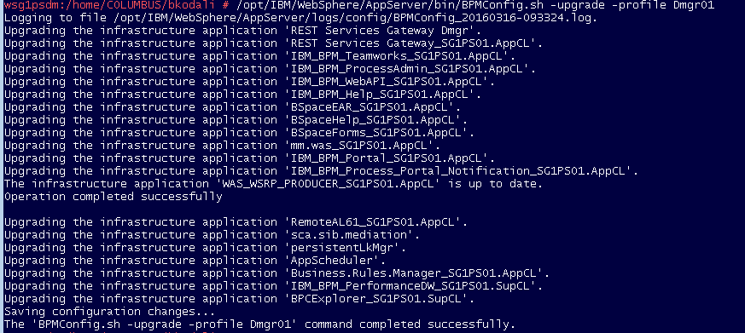

1. Export the configuration properties file.  
   create a folder – ‘mkdir –p /wasprofiles/profiles/Dmgr01/config/upgrade’

***/opt/IBM/WebSphere/AppServer/bin/BPMConfig.sh –export –profile Dmgr01 –de LABPS outputDir /wasprofiles/profiles/Dmgr01/config/upgrade***



The configuration properties file is named *LABPS*.properties and is in the output directory that you specified. You will refer to this file from the migration properties file in the next step.

1. Create a migration.properties file using the template. This file will be used in the later upgrade commands. The template properties file to copy is in ***/opt/IBM/WebSphere/AppServer/util/migration/resources/migration.properties. (see Example below)***

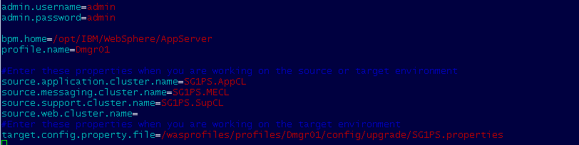

Ensure that the value of each of the following properties in the migration properties file is set correctly:   
- **bpm.home**: IBM Business Process Manager installation path   
**- profile.name**: Name of the deployment manager profile   
**- target.config.property.file**: Full path to the configuration properties file that you used to create your IBM Business Process Manager V8.5.x environment or that you generated in step 12.  
**Important**: Check the **bpm.de.sourceInfo.versionInfo** property in the configuration properties file and make sure that the source version is correct. If this property does not exist in the file, you do not need to add it.

1. Run DBUpgrade.sh command to upgrade your database, where *migration_properties_file* is the migration properties file that you created in above step.

***/opt/IBM/WebSphere/AppServer/bin/DBUpgrade.sh -propertiesFile /opt/IBM/WebSphere/AppServer/util/migration/resources/migration.properties (see the Example output below)***

|  |
| --- |
| wsg1psdm:/home/COLUMBUS/bkodali # /opt/IBM/WebSphere/AppServer/bin/DBUpgrade.sh -propertiesFile /opt/IBM/WebSphere/AppServer/util/migration/resources/migration.properties  IBM Business Process Manager 8.5.6 Upgrade  Executing Command: /opt/IBM/WebSphere/AppServer/bin/DBUpgrade.sh -propertiesFile /opt/IBM/WebSphere/AppServer/util/migration/resources/migration.properties  Loading environment settings  Using configure properties to read Deployment Environment information: /wasprofiles/profiles/Dmgr01/config/upgrade/SG1PS.properties  Profile path: /wasprofiles/profiles/Dmgr01  Whether it's ND environment: true  Migration logs are saved under /wasprofiles/profiles/Dmgr01/logs.  Begin to set WCCM system properties.  End of setting WCCM system properties.  Start to generate database upgrade SQL scripts for source version:8.5.6.0  Create upgrade sql files for component PDW, sql files created under /wasprofiles/profiles/Dmgr01/dbscripts/Upgrade/SG1PS_Cell01.SG1PS/DB2/PDWDB.db2inst1  Create upgrade sql files for component ProcessServer, sql files created under /wasprofiles/profiles/Dmgr01/dbscripts/Upgrade/SG1PS_Cell01.SG1PS/DB2/BPMDB.db2inst1  CWMCO6009I: The BPMGenerateUpgradeSchemaScripts command completed successfully.  Database upgrade SQL scripts was generated successfully.  Loading Process Server database info using JNDI jdbc/TeamWorksDB  Loading Performance database info using JNDI jdbc/PerformanceDB  Loading BPC database info using JNDI jdbc/BPEDB  Loading Common database info using JNDI jdbc/CommonDB  Loading Cell scoped database info using JNDI jdbc/WPSDB  Loading Business Space database info using JNDI jdbc/mashupDS  This action will permanently modify the data in your database (BPMDB.db2inst1, PDWDB.db2inst1, BPEDB.db2inst1)! It is critical that you perform a backup of the database so that it can be restored if err ors occur during the upgrade. Please confirm that the database has been backed up before continuing with the upgrade.  Please input [y/n]:  y  Your answer is "Yes". The upgrade will continue...  Checking upgrade prerequisites  Starting upgrade tool  IBM Business Process Manager V8.5.6 Enterprise database upgrade program started.  Verifying the current database configuration.  Successfully connected to Process Server database.  Checked Process Server database, appears to be a valid Process Server database.  Successfully connected to Performance Data Warehouse database.  Checked Performance Data Warehouse database, appears to be a valid Performance Data Warehouse database.  Successfully connected to Cell scoped database.  Checked Cell scoped database, appears to be a valid Cell scoped database.  Successfully connected to Common database.  Checked Common database, appears to be a valid Common database.  Successfully connected to BPC database.  Checked BPC database, appears to be a valid BPC database.  Successfully connected to Business Space database.  Checked Business Space database, appears to be a valid Business Space database.  Executing upgrade step: Validating current database version and checking upgrade SQL scripts  Executing upgrade step: Add bpmAuthor and administrative security user to LSW_USR, LSW_USR_XREF and LSW_USR_GRP_MEM_XREF tables  Executing upgrade step: Remove old event manager instance if WLE7x and BPM75 are not in the same machine  *** Executing upgrade step: Upgrade from version 8.5.0 to 8.5.5. ***  Executing upgrade step: Updating PO data of business items in LSW_PO_VERSIONS table..  Begin time: Wed Mar 16 10:01:36 EDT 2016  20% completed, remaining time: 00:00:03  100% completed  End time: Wed Mar 16 10:01:39 EDT 2016  Executing upgrade step: Upgrade 8.5.0 schema to 8.5.5 for database ProcessServerDatabase.  Executing upgrade step: Upgrade 8.5.0 schema to 8.5.5 for database PerfServerDatabase.  *** Executing upgrade step: Upgrade from version 8.5.5 to 8.5.6. ***  Executing upgrade step: Upgrade 8.5.5 schema to 8.5.6 for database ProcessServerDatabase.  Executing upgrade step: Populating new columns in the LSW_BPD_INSTANCE table....  Executing upgrade step: Upgrade 8.5.5 schema to 8.5.6 for database PerfServerDatabase.  Executing upgrade step: Deactivate the Process Portal process app  Successfully executed 6 upgrade steps.  Process Server database is now version 8.5.6.  Performance Data Warehouse database is now version 8.5.6.  Process Server and Performance Data Warehouse database upgrade completed successfully.  Executing upgrade step: Replace the recorded cell name at the BPC database.  Successfully executed 1 upgrade steps.  Advanced database upgrade completed successfully.  IBM Business Process Manager V8.5.6 Enterprise database upgrade program finished.  Creating /wasprofiles/profiles/Dmgr01/logs/SG1PS.DBUpgrade.success  All upgrade steps have been completed successfully. |

**Important**: Make sure that the DBUpgrade command has finished successfully before you move to the next step. The log is saved in */wasprofiles/profiles/Dmgr01/logs/DBUpgrade_timestamp.log*. Check the log for errors or exceptions. If running DBUpgrade was unsuccessful, correct the errors and restore your databases from the backup before running the command again.

|  |
| --- |
| wsg1ps02:/home/COLUMBUS/bkodali # /opt/IBM/WebSphere/AppServer/bin/BPMConfig.sh -upgrade -profile SG1PS02  Logging to file /opt/IBM/WebSphere/AppServer/logs/config/BPMConfig_20160316-141847.log.  The 'BPMConfig.sh -upgrade -profile SG1PS02' command completed successfully.  wsg1ps02:/home/COLUMBUS/bkodali # /wasprofiles/profiles/SG1PS02/bin/startNode.sh &  [1] 25269  wsg1ps02:/home/COLUMBUS/bkodali # CWUPO0001I: Running configuration action detectNewProducts.ant  CWUPO0001I: Running configuration action updateOdrServerXml_SS.ant  CWUPO0001I: Running configuration action PM96233.ant  CWUPO0001I: Running configuration action updateProfileForAssistedLiberty.ant  CWUPO0001I: Running configuration action DeleteExtensionRegistry.ant  CWUPO0001I: Running configuration action updateIntellMgmtXml.ant  CWUPO0001I: Running configuration action 765494.ant  CWUPO0002I: Running long-running configuration action BPMConfigUpgrade8560.ant  CWUPO0002I: Running long-running configuration action BootstrapProcessServerData8560.ant  CWUPO0002I: Running long-running configuration action BPMToolkitUpgrade.ant  CWUPO0001I: Running configuration action ejb-deploy-clear-cache.ant  CWUPO0001I: Running configuration action clearOSGiCache.ant  CWUPO0001I: Running configuration action runiscdeploy.ant  CWUPO0001I: Running configuration action clearClassCache.ant  ADMU0116I: Tool information is being logged in file  /wasprofiles/profiles/SG1PS02/logs/nodeagent/startServer.log  ADMU0128I: Starting tool with the SG1PS02 profile  ADMU3100I: Reading configuration for server: nodeagent  ADMU3200I: Server launched. Waiting for initialization status.  ADMU3000I: Server nodeagent open for e-business; process id is 26453 |

Create Indexs to resolve the post profile upgrade start-up issues:

CREATE INDEX DB2INST1.LSWC_UXREF_TEMP ON DB2INST1.LSW_USR_XREF (UPPER(USER_NAME) ASC, USER_ID, FULL_NAME, PROVIDER) MINPCTUSED 0 ALLOW REVERSE SCANS PAGE SPLIT SYMMETRIC COLLECT STATISTICS;

**DROP** **INDEX** DB2INST1.LSWC_UXREF_UQ2;

**CREATE** **UNIQUE** **INDEX** DB2INST1.LSWC_UXREF_UQ2 **ON** DB2INST1.LSW_USR_XREF ( USER_ID, USER_NAME ) INCLUDE ( FULL_NAME, PROVIDER ) ALLOW REVERSE SCANS **PAGE** SPLIT SYMMETRIC COMPRESS **NO**;

**CALL** SYSPROC.REBIND_ROUTINE_PACKAGE ( 'P', 'DB2INST1.LSW_TASK_CLOSE', 'RESOLVE ANY' );

**CALL** SYSPROC.ADMIN_CMD( 'RUNSTATS ON TABLE DB2INST1.LSW_USR_XREF FOR INDEX DB2INST1.LSWC_UXREF_UQ2' );

Reorg and Runstats of the entire system

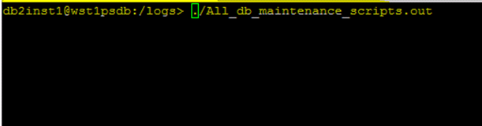

1. Restart the deployment manager server (dmgr). It takes a few minutes to complete the profile upgrade and run the bootstrapProcessServerData command.   
   **Notes**: The deployment manager profile is updated automatically during the first server startup after the refresh pack installation. The Business Process Choreographer, Business Space, CommonDB, and Messaging Engine databases are not changed when you upgrade from IBM Business Process Manager V8.5.x to the V8.5.6 refresh pack.
2. Check for errors, as described in [Identifying and recovering from profile upgrade or bootstrapProcessServerData errors](http://www-01.ibm.com/support/docview.wss?uid=swg27044938#errors), before you continue.
3. **Only for Process Center:** As part of upgrading the IBM BPM deployment environment to V8.5.6.0, a truststore for connections to IBM Blueworks Live (one per WebSphere cell, named BlueWorksLiveTrustStore) and a keystore for IBM BPM (one per IBM BPM deployment environment, named IBMBPMKeyStore-*de_name*) are added to the configuration. The truststore and the keystore use the same password as the WebSphere CellDefaultKeyStore initially. If the WebSphere default keystore is not found, then the documented WebSphere default keystore password is used. You are advised to assign separate passwords to the BlueWorksLiveTrustStore truststore and to the IBMBPMKeyStore-*de_name* keystore.
4. For each managed node in the network deployment environment, complete the following steps:
   1. Restart the node agent. It takes a few minutes to complete the profile upgrade. Allow for node synchronization to complete. **Note**: The managed profile is updated automatically during the first server startup after the refresh pack installation.

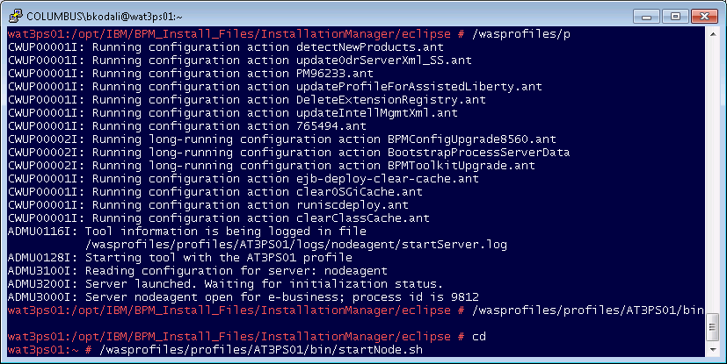

* 1. Check for errors, as described in [Identifying and recovering from profile upgrade or qbootstrapProcessServerData errors](http://www-01.ibm.com/support/docview.wss?uid=swg27044938#errors), before you continue.
  2. Login to WAS Adminconsole > System Administration > Deployment Manager and make the SDK default to new version Installed.

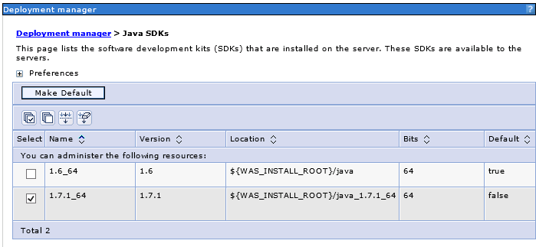

* 1. Repeat the step 3 for Node Agents and AppServers for each Node.

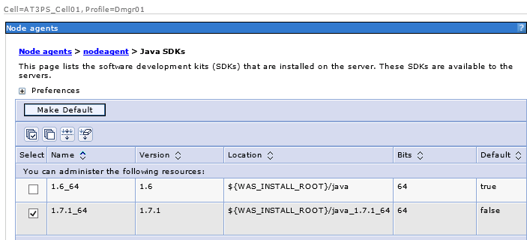

* 1. Restart all the JVMs (dmgr and nodeagent).
  2. Start the BPM Environment.
  3. To monitor database activity use EX: db2inst1@wat3psdb:~> **db2top -d bpmdb**

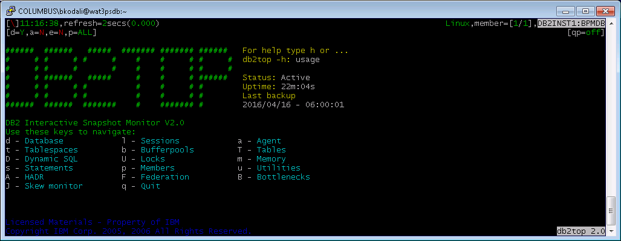

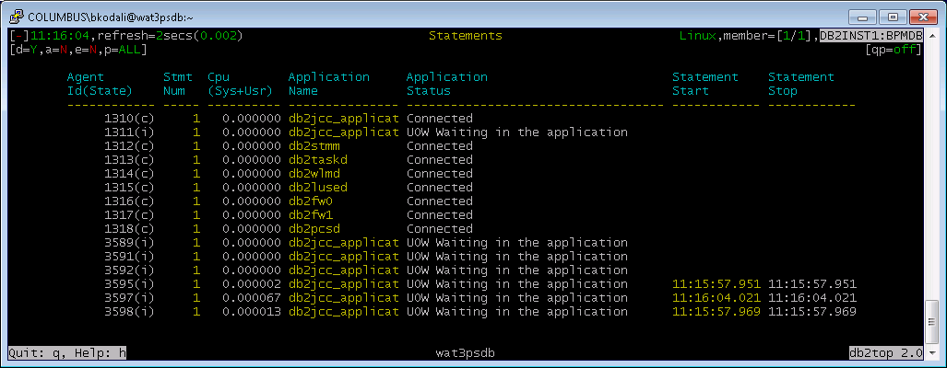

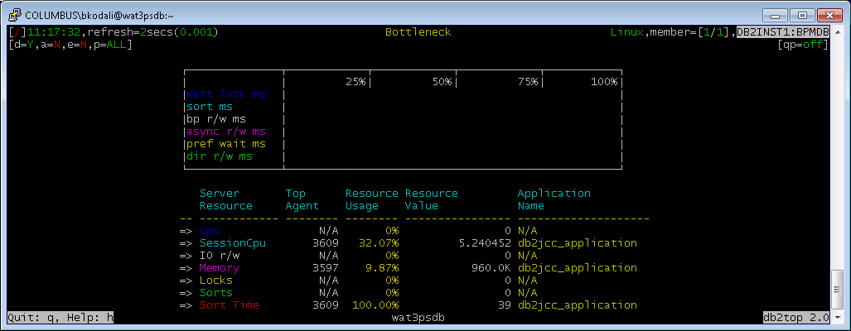

1. **Configure Process Server for online communication with Process Center.**
   1. Update the clunster-bpm.xml in Deployment Manager ( nee to restart dmgr and nodes after all the steps complete)

*wat3psdm:/wasprofiles/profiles/Dmgr01/config/cells/AT3PS_Cell01/clusters/AT3PS.AppCL # grep wau8 *.\**

*cluster-bpm.xml: <bpdServer xmi:type="BPMConfiguration:BPMProcessServer" xmi:id="BPMProcessServer_1389406224763" useHTTPSURLPrefixes="true" httpProtocolOnly="true" processCenterUrl="http://****wau8ws01****/ProcessCenter" heartBeatInterval="10" processCenterInternalUrl="http://****wau8ws01****/ProcessCenterInternal">*

* 1. Update the ID (BPMPC_Admin) and password for new Process Center as shown in screenshot

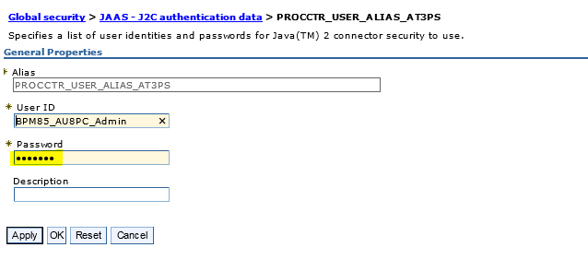

* 1. Detelet the existing Signer Certificate of DefaultTrustStore and Retrieve from port of new BPMPC.

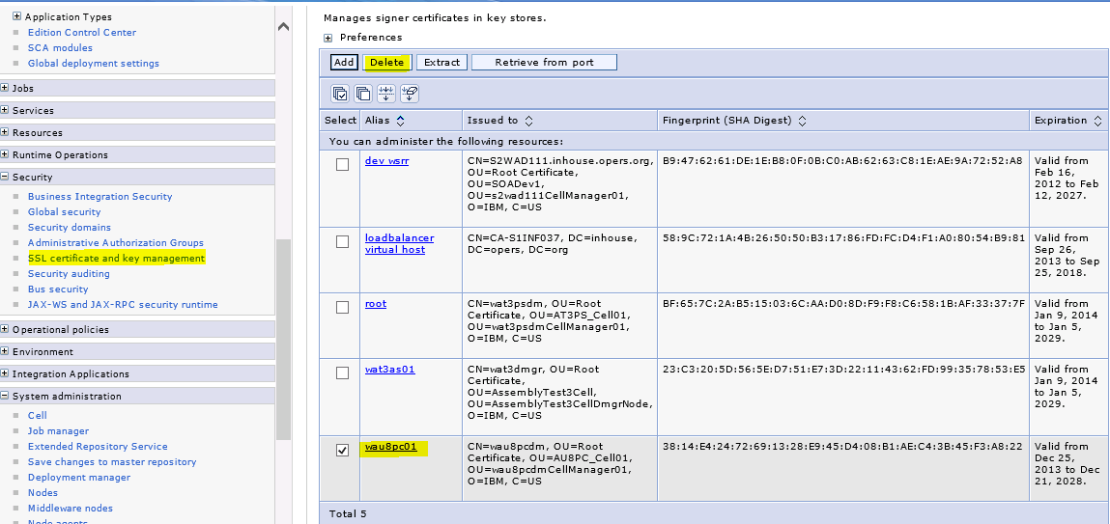

1. Login to new Process Center <http://wbpmpc01:9080/ProcessCenter> and click on tab ‘Servers’ and look for the upgraded ProcessServer show up as shown in screenshot below.

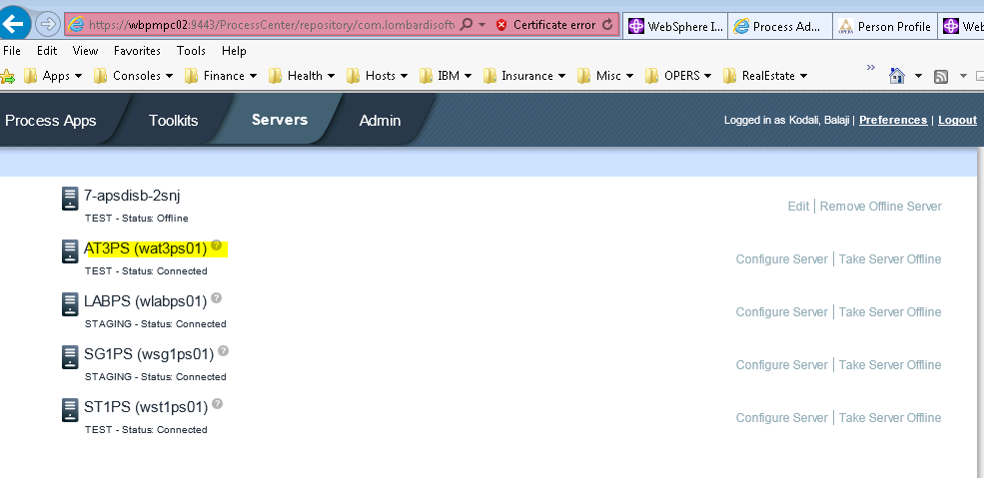

1. Team works DB Data source configuration to resolve the errors as per the following link: <https://developer.ibm.com/answers/questions/184558/after-upgrading-to-bpm-856-you-might-see-the-follo.html>
   1. Log in to the WebSphere Application Server admin console.
   2. Select Resources > JDBC > Data sources > DataSource name (TeamWorksDB) > Custom properties and click New.
   3. In the Name field, enter downgradeHoldCursorsUnderXa.
   4. In the Value field, type true.
   5. Change the type to java.lang.Boolean.
   6. Click OK to save your changes.
   7. Select custom property resultSetHoldability.
   8. In the Value field, type 1.
   9. Click OK to save your changes. .

This technote <http://www-01.ibm.com/support/docview.wss?uid=swg21287386> explains what this setting does to help resolve the sql errors issue.

1. Restart BPM Environment.
2. Once you have the Process Server upgrade complete, go to Process Apps tab and install the TENR (T5-11) or any other snapshot as shown in screenshot. This will take a while to see the status ‘Currently Installed’. However you can view the ‘Installation Details’ by expand it.

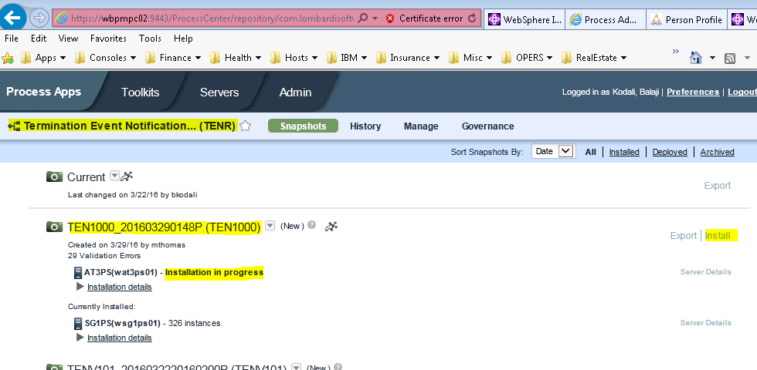

20) Login to Process Server – ProcessAdmin console and go to installed Apps > Snapshot deployed and select one option at a time and migrate Inflight Data, Sync Settings and Update Tracking Definitions.

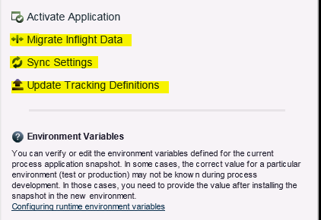

1. Please contact Dev teams for any additional BPELs or BPD deployments as post upgrade steps and compass testing.